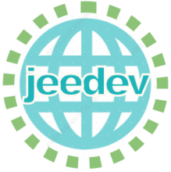
Journal of Energy and Economic Development
Call for Papers
Submission open for 2023
Journal of Energy and Economic Development (JEEDEV) is the premier field journal for energy economics. Themes include, but are not limited to, the exploitation, conversion, and use of all types of energy, energy markets, regulation and taxation, energy tariff setting, forecasting, environment and climate, international trade, and market reforms. JEEDEV will publish original quality papers in both theoretical and empirical areas and contributions to the journal can use a range of methods such as econometrics, experiments, surveys, decomposition, calibration, simulation, equilibrium models, optimization, and analytical models. Original research papers on energy market issues and policy analysis in developing countries are particularly welcome.
The Journal publishes in online and print versions.
To submit a paper, please visit https://jeedev.nri.ac.ir
E-mail: JEEDEV@nri.ac.ir
Editor-in-Chief: Saeed Moshiri
Director-in-Charge: Kioumars Heydari
Executive Director: Ladan Khorsand
Online ISSN: 2821-207X
Phone: +98-(21) 88378969
+98-(21) 88079400-4920

